Temporary Tables are quite similar to Permanent Tables in database; Permanent Tables are created in a specific database and persist until the database exists, while Temporary Tables are created in the tempdb and are automatically deleted when they are no longer in use. Like shown below:

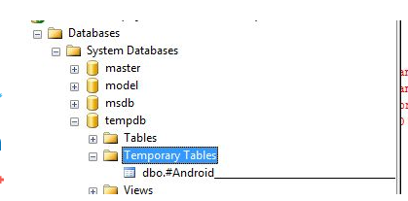

**Types of Temporary Tables**

* Local Temporary Tables
* Global Temporary Tables

**Local Temporary Tables**

* Similar to Permanent Tables in SQL Server,
* Accepts the single hash value "#" as the prefix when created.
* Syntax: (CREATE TABLE #t).
* Visible only to the connection that creates it.
* Each Local Temporary Table has a random value at the end of the table name.

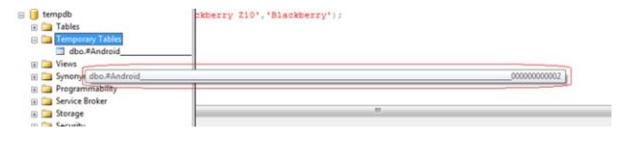

* Deleted when the connection is closed.
* User can also explicitly drop it with the following command "drop table #tablename".
* If the Temporary Table is created in a Stored Procedure then it is automatically dropped on the completion of the Stored Procedure execution.
* You can create a Local Temporary Table with the same name but in a different connection, and it is stored with the same name along with various random values.

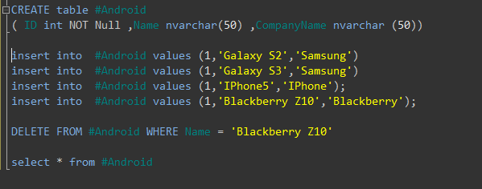

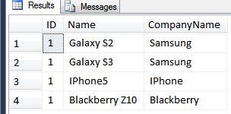

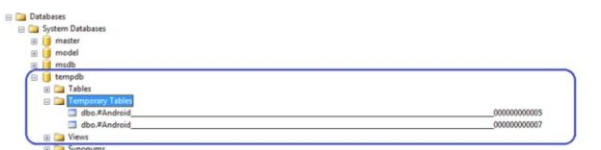

**Global Temporary Tables**

* Similar to Local Temporary Tables in SQL Server.
* Two "##" values are used as the prefix at the time of their creation.
* Syntax: (CREATE TABLE ##tablename).
* Visible to all connections of SQLServer.
* Destroyed when the last connection referencing the table is closed (in which we have created the Global Temporary Table).
* There is no random number appended to the name.
* Can access the Global Temporary Tables from all connections of SQL Server until the referencing connection is open.

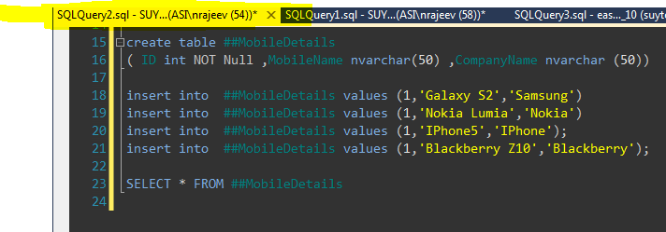

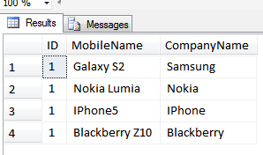

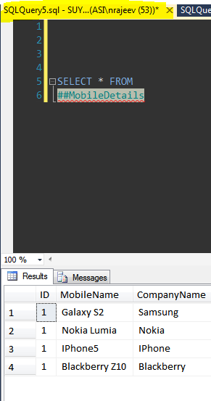

**Derived Tables**